**Saint Martin's Island**

[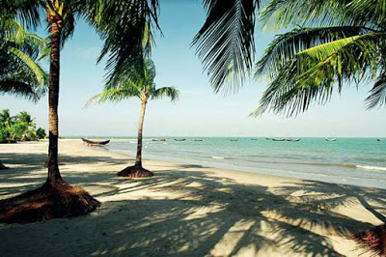](https://2.bp.blogspot.com/-0v5zHekdW-A/W75KAy0F19I/AAAAAAAAANE/XtFRjFVGbF4LqNcQncdJj1gV4aJSTanuQCLcBGAs/s1600/Landscape%2Bof%2BSt%2BMartin%2BIsland.jpg)

 Bangladesh has many tourists spots. It is One of the most beautiful countries in the world for its   various tourist's spots. One them us [Saint Martin's island](https://en.wikipedia.org/wiki/St._Martin%27s_Island). It's in the Bay Of Bengal. It's situated   about 9km south from Cox's Bazar-Teknaf peninsula. There is also an adjoining Island. Which is   called [Chera dip](https://en.wikipedia.org/wiki/Chhera_Island).

[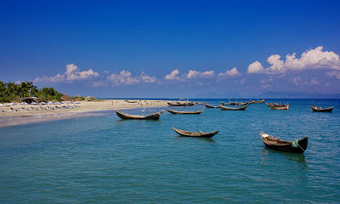](https://1.bp.blogspot.com/-xS-NdGVtNf8/W75J3V6f34I/AAAAAAAAANA/oJHOyD4jesMwJRe7Z90DTyLJF-p66Od5QCLcBGAs/s1600/Saint%2BMartin%2BIsland.jpg)

Who doesn't like to travel? Everybody does. Everyone wants to go far away from daily life. They want some refreshing time. For that, we search for tourist spots. They aren't that hard to find. As i said, one of them is [Saint Martin's island](https://en.wikipedia.org/wiki/St._Martin%27s_Island). It's full of natural beauty including the beach and sea.

But recently the authorities of Saint Martins island took some actions from protecting this island. I will talk about all the actions of the authorities, in this article.

Anybody can go to Saint Martin's island at any time. But from 1 March 2019. this is going to change. **Saint Martins authorities** have taken some actions for saving this island. Authorities noticed that tourists and local peoples are **gradually destroying this island**. Local people and tourists, not taking good care of this beautiful tourists spot. They are polluting this island in many ways. For that, the environment of the island is changing. If this goes by, this island will **no longer exist**.

[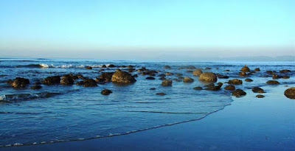](https://2.bp.blogspot.com/-LvNg4tzoWCk/W75KOsrN_PI/AAAAAAAAANM/ZaXcJAPWrCwL-AE6DhpCWb0XL7hU5V-lACLcBGAs/s1600/Saint_Martin_Island.jpg)

**Actions of the authorities**

* From **1 March 2018** if anyone wants to go to Saint Martins island he/she has to **apply online**.
* The major part is no one can spend the night on the island. You can go to the island in the morning and have to return before sunset.
* Important parts of the island known by Golachipa and cheradip are totally prohibited for everyone. You cant go to these places even in the daylight.
* Driving cars, motorcycle, speedboat are also forbidden on the island.
* A number of ships which go to Saint Martins island will be **reduced 20 to 02.**
* The number of tourists in a day have to be less than 500.
* Building new constructions are also banned.
* Electric generators are also forbidden.
* People of the island have to cope with the **solar system**.

[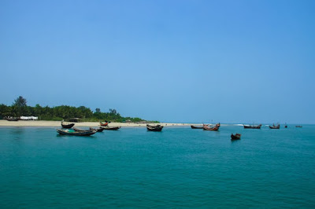](https://4.bp.blogspot.com/-1kC1WxHaNdQ/W75KTOfjSnI/AAAAAAAAANU/oewNOwcEZl0BlTrd0VvDFmkBv8GfQxeUwCLcBGAs/s1600/blue.jpg)

**On the island, there are:**

1. 68 types of coral.
2. 191 types of molluscs.
3. 234 types of sea fish.
4. 120 types of bird.
5. 2 types of Bats.
6. 5 types of Dolphin are seen.

The authorities taking the action for saving all of this for a long term. This action was taken by the authorities on **23 September.** This time they are also serious. They are going to do take actions within **6 months or 1 year.**

**Source:** From a local newspaper of Bangladesh.